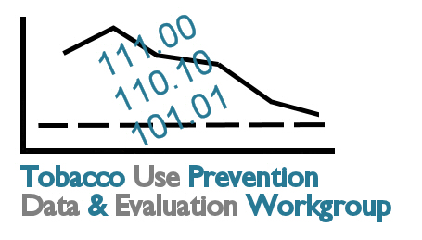
Tobacco Data and Evaluation
Planning Process: Meeting 4
October 5, 2007

10:00 Introductions

10:10 Review of Meeting 3 Progress Harlen Hays
Overview of Meeting 4 Objectives

10:20 Overview of Small Group Progress at Meeting 3
Large Group Discussion and Final Prioritization

10:20 Goal Area 1: Youth Prevention Karry Moore
10:35 Goal Area 2: Secondhand Smoke Carol Cramer
10:50 Goal Area 3: Cessation Ghazala Perveen

11:05 Break

11:10 Cross-Cutting Themes
- Review Cross-Cutting Issues handout
- Prioritize Cross-Cutting Strategies Discussion

11:30 Disparities
- Review of Disparities Strategies in Other Plans Connie Satzler
- Prioritize General Disparities Strategies Discussion

12:00 Working Lunch (Catered)

12:30 Collaboration Opportunities
- Review Similar Evaluation Efforts by Strategic Partners Connie Satzler
- Identify Collaboration Opportunities: Where are the opportunities to work on cross-cutting issues or disparities?

1:15 Determine Primary Responsibility for Producing Evaluation Report Discussion

1:30 Implementation of Evaluation Plan Harlen Hays, Discussion
- Identify Broad Implementation Strategies, including frequency and schedule of report, dissemination method (e.g., paper, online), how/when to submit data, etc.

2:00 Break

2:10 How can partners use evaluation report as a tool for maximum benefit? How can partners leverage support to help each other move evaluation forward? Discussion

2:40 Review Meeting 4 Progress Harlen Hays
Discuss Next Steps

3:00 Adjourn

